How to Place a Referral to the McLaren Bariatric Surgery Program

* Navigate to the order entry area. Search for “Referral – Ambulatory”
  1. 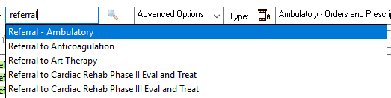
* Select the next button. Select “Bariatric” in the medical service box.
  1. A screenshot of a computer

     AI-generated content may be incorrect.
* In the “Refer to” box, click the binoculars button.
  1. A white rectangular frame with black lines

     AI-generated content may be incorrect.
* Select the appropriate location.
  1. A close up of a text

     AI-generated content may be incorrect.
  2. A close up of a sign

     AI-generated content may be incorrect.
  3. A close up of a sign

     AI-generated content may be incorrect.
* Sign the order. The referral will now be in your clinic’s outgoing referral que for processing.